Project Proposal

Project Title: Parking Management System

Client Name: Taimoor Khan

Submitted by: Sus Birds

I. SUMMARY
A software to keep track of data and handle finances to generate reports, for XYZ parking.
We will create a full desktop application with database integrated. The software will have features similar to Point Of Sale System.
The project should be done as to provide solution to city’s traffic problems. This project will be a relief for citizens and local authorities as this will provide safety and security for them. This project will be a big success from business point of view because XYZ parking will be easily able to attract customers, by promising them safety and security plus peace of mind.
We Sus Birds are a team of experts; we have made dozens of Point-of-Sale Systems for both big and small corporate. We are known for our work ethics and timeliness. Our client satisfaction score is 9.5/10. And our rates are also relatively lower than market.

Project Details: Parking management System
Location: Peshawar
Proposed Starting date: 4th April
Project Duration: 2 months
Total Budget: 180,000 Rs
Proposed Payment Installments: 90,000 Rs per month
Others (if any)

II. BACKGROUND AND JUSTIFICATION
The city is facing lots of problems due to road side and street parking. The roads get blocked and traffic flow is halted. People get frustrated and this frustration and anger causes them mental and psychological problems. So, there should be a parking facility to cope with this problem. The facility will help general public and also it will provide great business opportunity creating employment too.
To manage all the facility XYZ parking needs a software.


III. Requirements

Functional Requirements
- The system must be able to registers new customers.
- The system must take care of finances.
- The System must be able to track of slot info.
- The system must be able to generate finance report.
- The system must send the report to owner.
- The system must store member and non-member record.
- The system should charge vehicle types differently.
- The system must view details on any given slot or show if it is empty.
- The system must let the user search for vehicles.
- The system must give admin all root privileges.

Non-Functional Requirements
- Shall be able to deal with a very large number of records.
- Shall be able to register new customers with in 1 second.
- Shall be able to generate daily reports automatically.

IV. Team

Muhammad Faizan Wasif : 2 years of coding experience in both front-end and back-end development.

Atif Mehrban: 2 years of experience in Software Designing.


Syed Ali Hasnain: 3 years of experience in Software Designing.

Hamza Shahid: 3 years of coding experience in both front-end and back-end development.


Istafa malik: 2 years’ experience in software designing



V. OBJECTIVES
This project will provide solution to city’s traffic problems. This project will be a relief for citizens and local authorities as this will provide safety and security for them.

VI. Budget

EXPENSE | TOTAL
Employee salaries | 10,000 PKR
Equipment to Purchase | 2,500 PKR
Travel | 10,000 PKR
Maintenance | 30,000 PKR
Miscellaneous | 15,000 PKR
TOTAL | 67,500 PKR

(Note: Budget may vary)

VII. Deliverable after every week
A milestone is reached every two weeks. What deliverable would you share after every two weeks?
with your stakeholders to mark your performance.

1st Deliverable:
-Wire-frame design for whole software
2nd Deliverable:
-Splash screen
3rd Deliverable:
-Splash screen and main interface
4th Deliverable:
-Prototype and database ERD
5th Deliverable:
-Database built
6th Deliverable:
-Database integrated
7th Deliverable:
-Beta version
8th Deliverable:
-Full-fledged working software

VIII. Assumptions
- The vehicle that entered the parking area will also leave.
- The employees know how to use computers.
- The employees have done at least matriculation.
- The objective and scope of the project will not change during the developing period.
- The business rules will remain same until the project is developed. However, there is a possibility that rules may change. For example, number of parking slots set for vehicle type may increase of decrease as per business requirement.

IX. Proposed Solution
A lot of vehicles will enter into the building and many owners will get themselves registered for the membership. In addition to this to measure business success every vehicle’s data that enters the building should be stored. So, for that a parking management software will be built with database integrated to store the record. And it to avoid human errors.

X. Communication Log
Log history of all the communications that took place between the team members in order to
prepare this proposal
Use the following format for it:
Date: 3rd April
Members attended: 4
Attended by: Faizan, Hamza, Husnain, Atif
Agenda discussed: Proposal
Agreed points: functional and non-functional requirements

Proof:

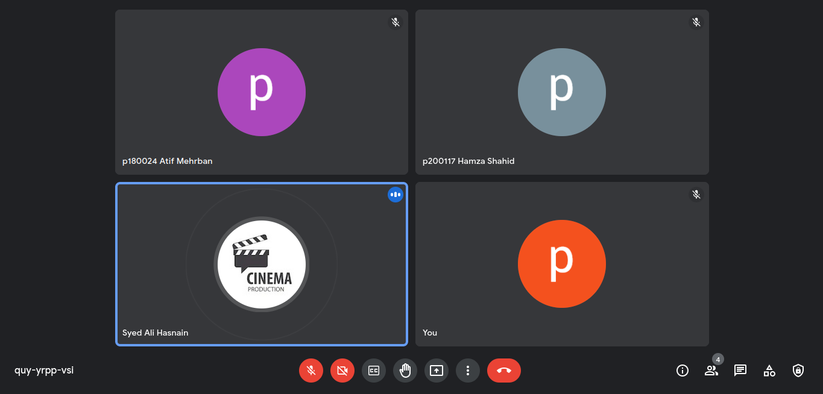

Agenda discussed: discussion on client’s new requirement and future planning about implementing them in future iterations
Agreed points: client will not be charged on extra amount for these requirement
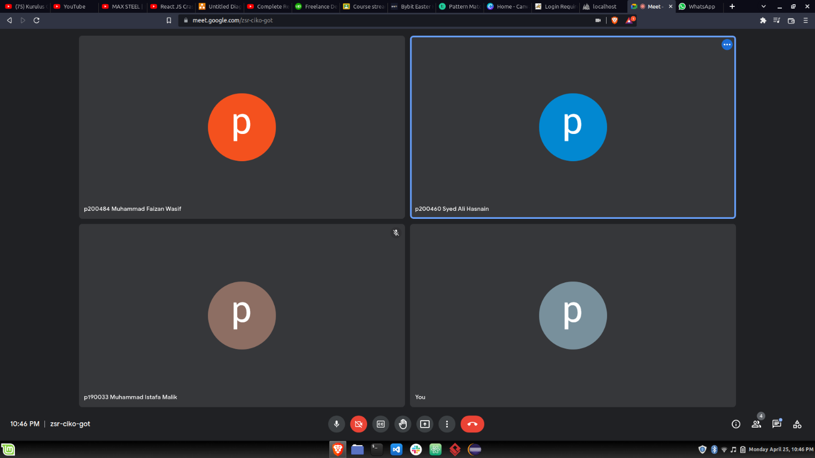
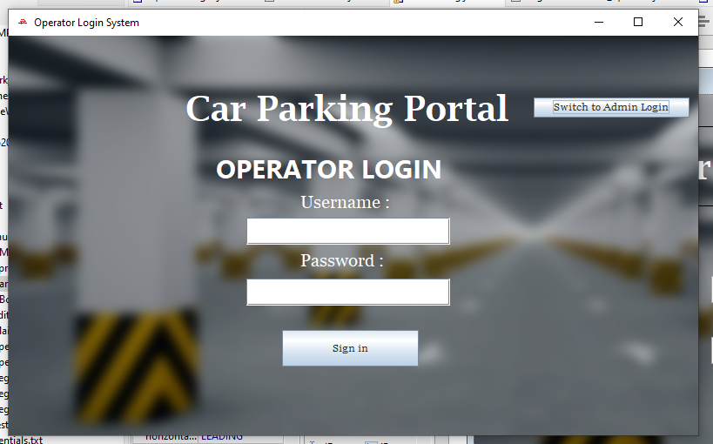

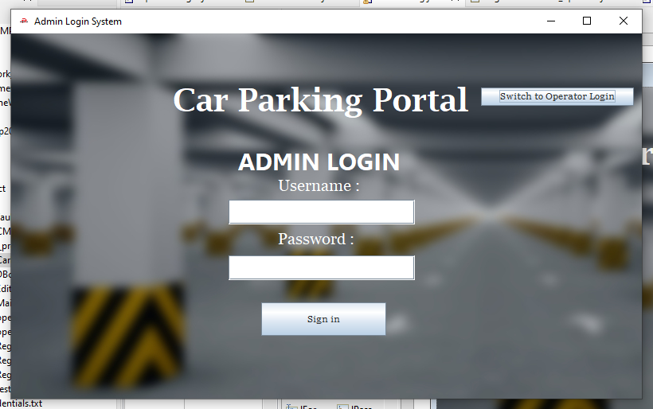
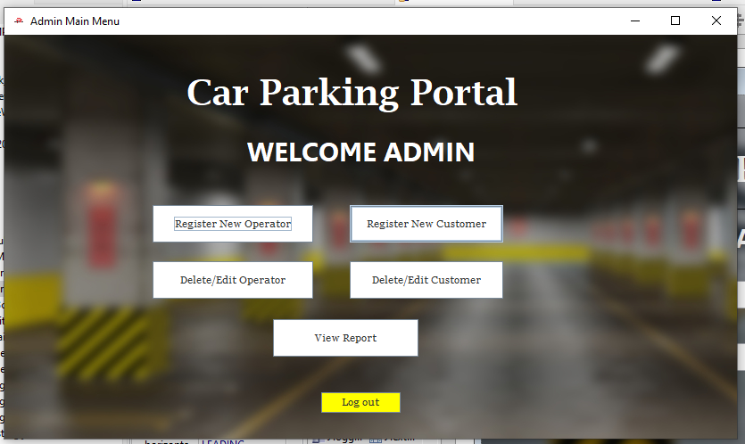
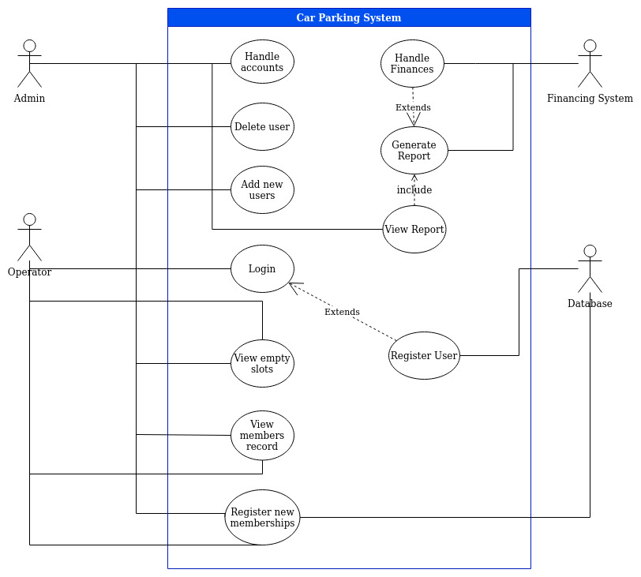

Use Case 1

Title: | Log In
Description: | The operator can log-In to the system
Primary Actor: | Operator  Admin
Preconditions: | The User should be registered into the database
Postconditions: | The operator can view empty slots
Main  Success Scenario: | Enter Username and password to log in the system to view empty slots

Title: | Add New User
Description: | The admin can add new user to the system
Primary Actor: | Admin
Preconditions: | The operator has log in to the system
Postconditions: | N/A
Main  Success Scenario: | After logging in the system, admin adds user info to the system.

Title: | Customer Entry
Description: | The admin can enter member from the system
Primary Actor: | Admin
Preconditions: | The admin should be log in to the system
Postconditions: | There will be must entry conditions for the new customers.
Main  Success Scenario: | After logging in to the system, Admin enter customer info of the member

Title: | Registration
Description: | The admin can register member from the system
Primary Actor: | Admin
Preconditions: | The admin should be log in to the system
Postconditions: | Check conditions
Main  Success Scenario: | After logging in to the system, Admin register info of the member

Title: | Register New Member
Description: | The operator or Admin both can register new member
Primary Actor: | Operator  Admin
Preconditions: | The admin or operator should be log in to the system
Postconditions:
Main  Success Scenario: | Enter members details and added it to the system

Title: | View Member
Description: | The operator or admin can view member info.
Primary Actor: | Operator  Admin
Preconditions: | The operator or admin both should be log in to the system.
Postconditions: | The operator can view empty slots
Main  Success Scenario: | After logging it to the system, operator and admin can view member

Title: | Delete User
Description: | The admin can delete member from the system
Primary Actor: | Admin
Preconditions: | The admin should be log in to the system
Postconditions:
Main  Success Scenario: | After logging in to the system, Admin delete info of the member

Title: | View report
Description: | The admin can view reports
Primary Actor: | Admin
Preconditions: | The admin should be log in to the system
Postconditions:
Main  Success Scenario: | After logging to the system, admin can view reports.

